**Computer Software**

**Class Five**

**Lab 6**

|  |
| --- |
| Lab Objectives:  * Skype * Gmail * LinkedIn * Facebook * Twitter |

# Software

## Computer software, or simply software, is a collection of data or computer instructions that tell the computer how to work.

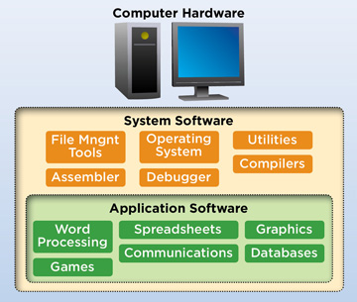

## System Software

## It is a base for application software which is responsible for managing hardware.

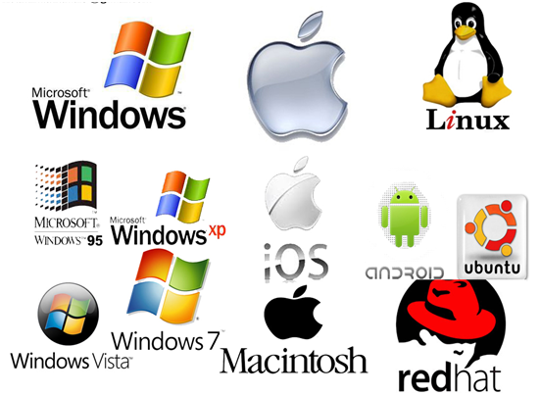

## In other words we can say that system software is a inter mediator between user and hardware. system software is also known as Operating System Example - MS-Windows, UNIX, Linux, Sun Solaris

## Application Software

## simply applications, which are often called productivity programs or end-user programs because they enable the user to complete tasks, such as creating documents, spreadsheets, databases and publications, doing online research,

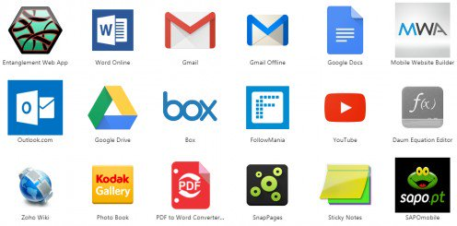

## sending email, designing graphics, running businesses, and even playing games! Application software is specific to the task it is designed for and can be as simple as a calculator application or as complex as a word processing application.

# Online vs Offline Software

## IMG_256Some software needs data connection to play wheres you can use lots of software without having data.

# Most Popular Online Software

## Skype

## Gmail

## LinkedIn

## Facebook

## Twitter

# Skype

## Skype is a telecommunications application that specializes in providing video chat and voice calls between computers, tablets, mobile devices, and smart watches via the Internet.

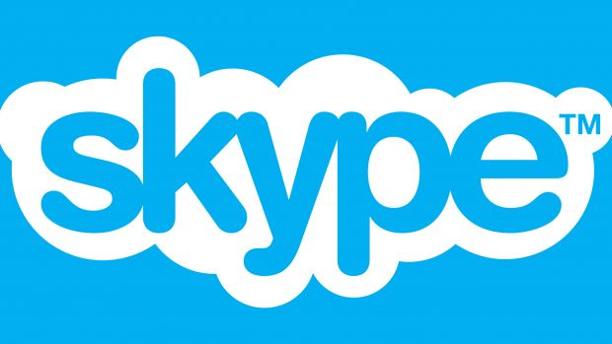

# GMAIL

## Gmail is a free email service developed by Google. User can send , receive email using GMAIL. Not only mailing service but GMAIL provides lots of extra facilities like Google Drive, Calender, photos, word, spreed sheet etc also.



# LinkedIn

## [LinkedIn](https://www.thebalancesmb.com/how-to-use-linkedin-to-promote-your-home-business-1794731) is a valuable resource for career and business professionals to network; obtain resources and support; and build relationships with potential customers, clients, and partners.



# Facebook

## Facebook is a social networking site that makes it easy for you to connect and share with family and friends online. Facebook was created in 2004 by Mark Zuckerberg.

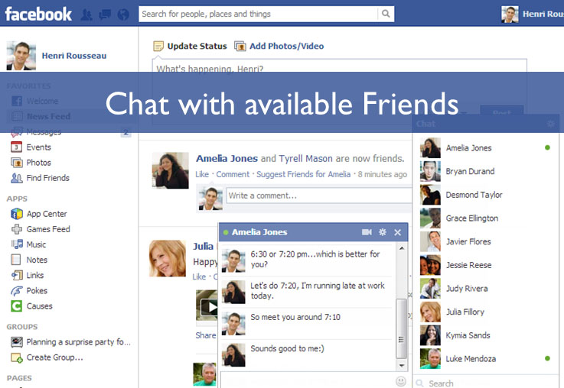

# Twitter

## Twitter is an American online news and social networking service on which users post and interact with messages known as "tweets".

